## Roadmap For Data Analysis Process

## Which stage?

#### This roadmap provides a guide for every stage of the analysis process so you can create a strong final product. Select the stage you are currently working on for details on questions and key tasks that will guide you through the case study.

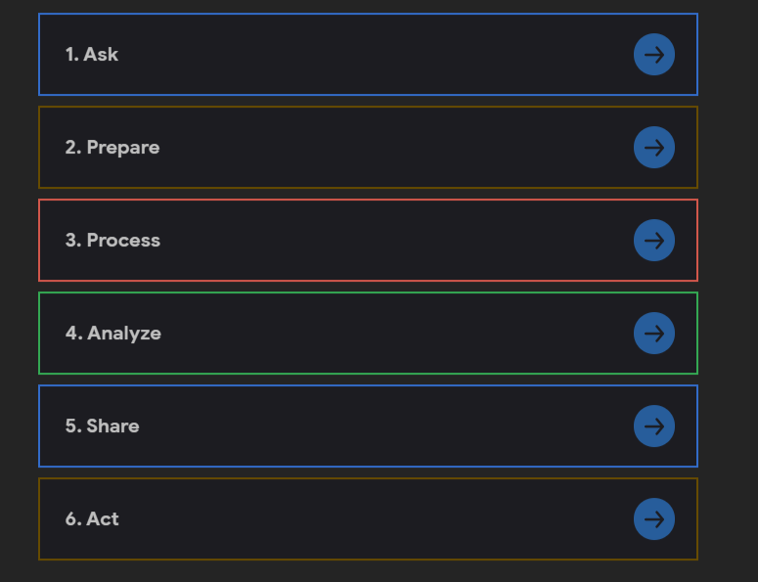



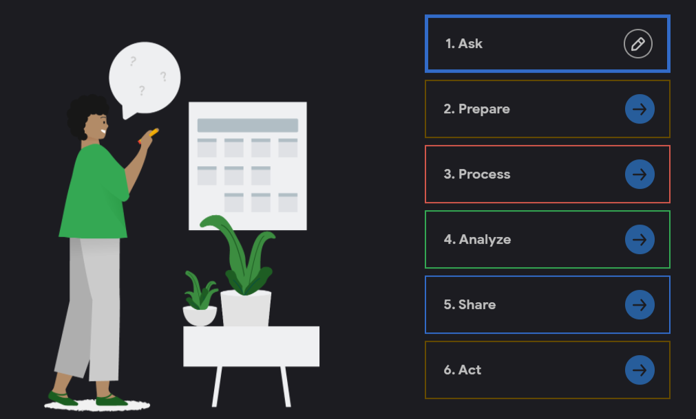

#### **Guiding questions**

* What topic are you exploring?
* What is the problem you are trying to solve?
* What metrics will you use to measure your data to achieve your objective? Who are the stakeholders?
* Who is your audience for this analysis and how does this affect your analysis process and presentation?
* How will this data help your stakeholders make decisions?

#### **Key tasks**

It’s important to understand the problem and any questions about your case study early on so that you’re focused on your stakeholders’ needs.

* Choose a case study
* Identify the problem
* Determine key stakeholders
* Explore the data and establish metrics

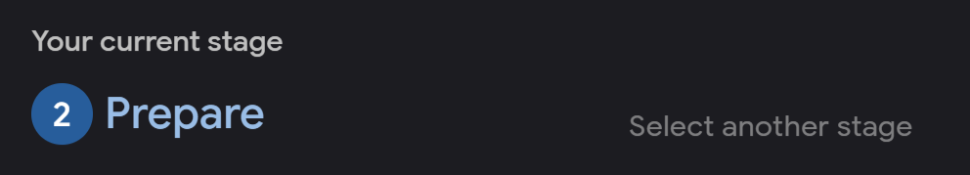

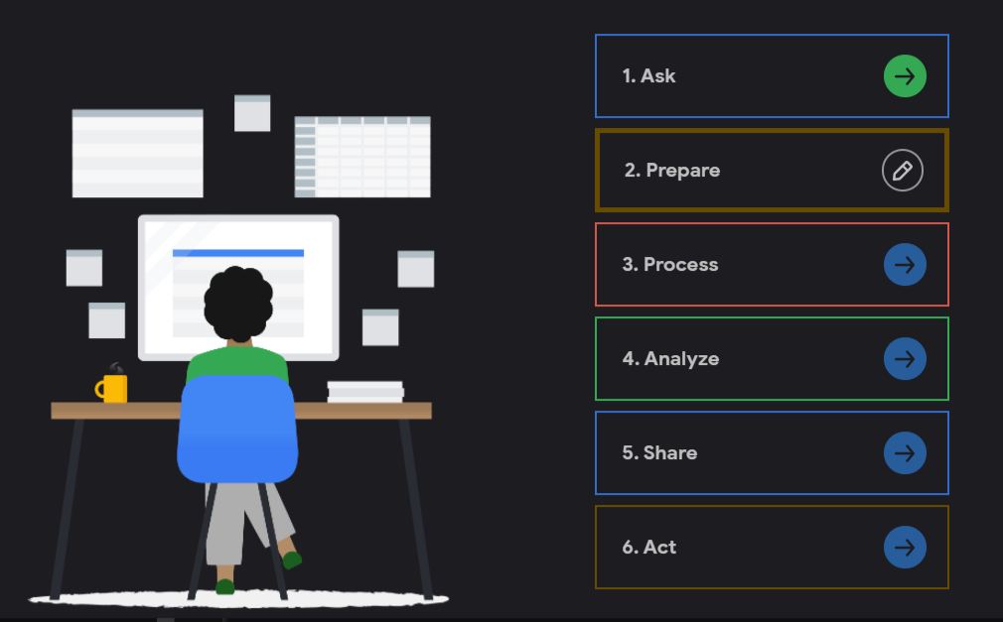

#### **Guiding questions**

* Where is your data located?
* How is the data organized?
* Are there issues with bias or credibility in this data? Does your data ROCCC?
* How are you addressing licensing, privacy, security, and accessibility?
* How did you verify the data’s integrity?
* How does it help you answer your question?
* Are there any problems with the data?

#### **Key tasks**

The prepare phase ensures that you have all of the data you need for your analysis and that you have credible, useful data.

* Collect data and store it appropriately
* Identify how it’s organized
* Sort and filter the data
* Determine the credibility of the data

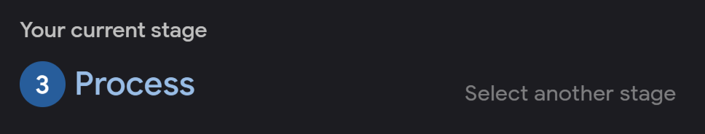

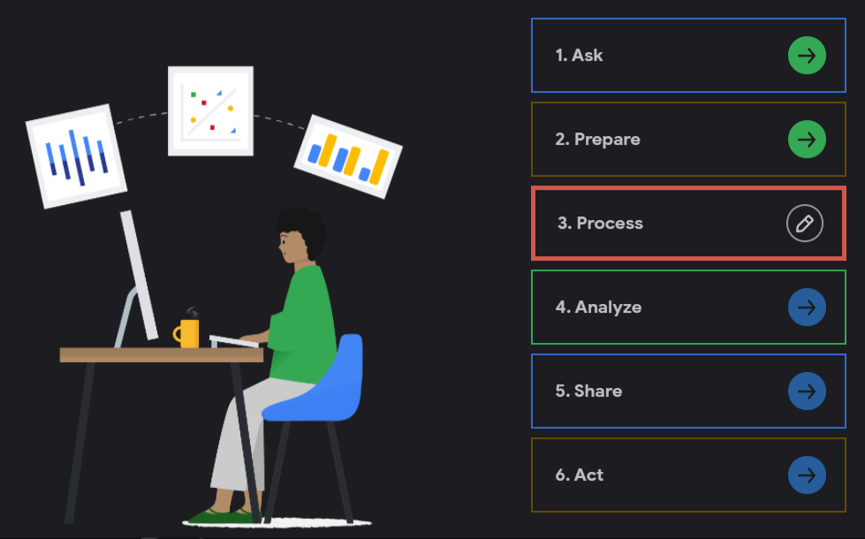

#### **Guiding questions**

* What tools are you choosing and why?
* Have you ensured your data’s integrity?
* What steps have you taken to ensure that your data is clean?
* How can you verify that your data is clean and ready to analyze?
* Have you documented your cleaning process so you can review and share those results?

#### **Key tasks**

Now that you know your data is credible and relevant to your problem, you’ll need to clean it so that your analysis will be error-free.

* Check the data for errors
* Transform the data into the right type
* Document the cleaning process
* Choose your tools

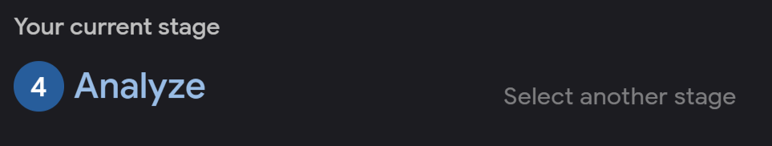

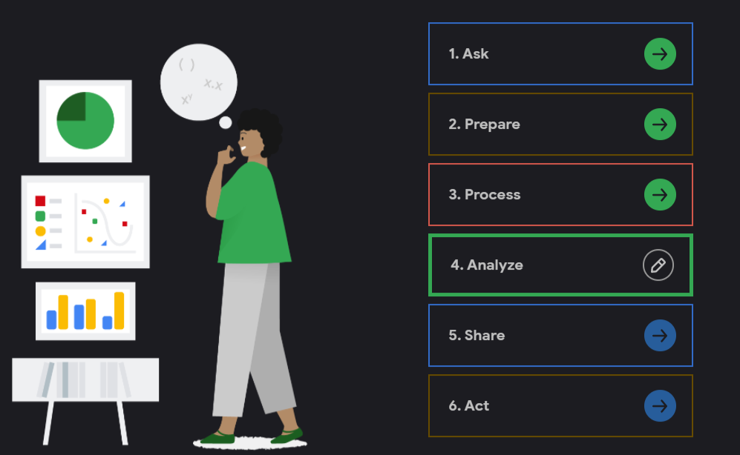

#### **Guiding questions**

* How should you organize your data to perform analysis on it?
* Has your data been properly formatted?
* What surprises did you discover in the data?
* What trends or relationships have you found in the data?
* How do these insights answer your question or solve the problem?

#### **Key tasks**

Now you’ll really put your data to work to uncover new insights and discover potential solutions to your problem!

* Aggregate your data so it’s useful and accessible
* Organize and format your data
* Perform calculations
* Identify trends and relationships



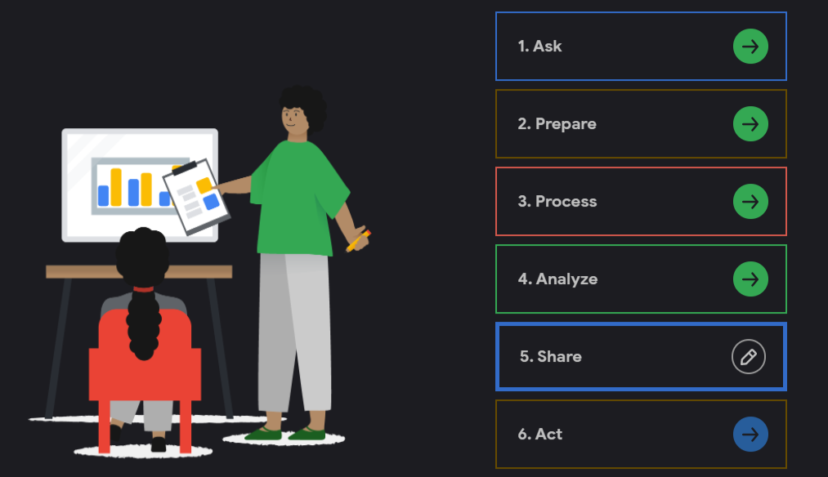

#### **Guiding questions**

* What story does your data tell?
* How do your findings relate to your original question?
* Who is your audience? What is the best way to communicate with them?
* Can data visualization help you share your findings?
* Is your presentation accessible to your audience?

#### **Key tasks**

During the share phase, you’ll tell a story using data and communicate your findings.

* Determine the best way to share your findings
* Create effective data visualizations
* Present your findings
* Ensure your work is accessible to your audience

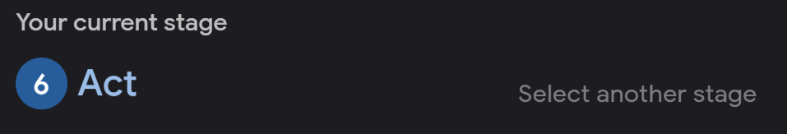

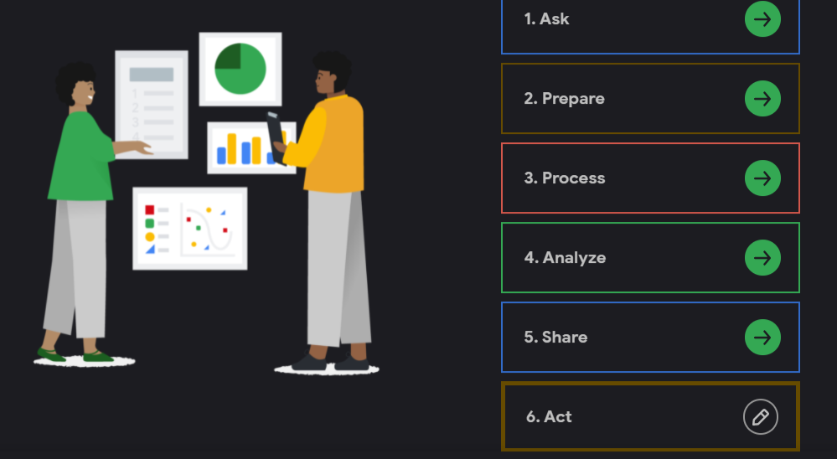

#### **Guiding questions**

* What is your final conclusion based on your analysis?
* How can you apply your insights?
* Are there any next steps you or your stakeholders can take based on your findings?
* Is there additional data you could use to expand on your findings?
* How can you feature your case study in your portfolio?

#### **Key tasks**

After this, your case study will be complete. But you can use these steps again to help guide you through your analysis process.

* Share next steps with your stakeholders
* Determine if more data could give you new insights
* Upload to your portfolio

Reference

1. <https://www.coursera.org/learn/google-data-analytics-capstone/ungradedWidget/8j3Hf/capstone-roadmap>